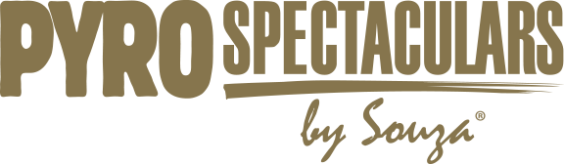
July 4th, 2020
Dear [[Elected Official – Congressperson, Senator, State Legislature, etc.]],
I am writing to request your help in saving small family businesses in the fireworks industry. As economic hardship continues to plague our country, millions of Americans will not enjoy the great and historic tradition of celebrating their freedom with public fireworks displays on Independence Day. Without your assistance, many multi-generational small family businesses that comprise the professional display fireworks industry will not be able to survive.
The pandemic has been devastating to the firework production industry. Most of these businesses earn a substantial amount of their revenue during the Fourth of July, professional sporting events, high school social events, and other community events. Due to social distancing requirements, restrictions on social gatherings, and other factors almost all their revenue opportunities have been eliminated. Due to the seasonal nature of their business, most professional firework production companies will face a 70-95% reduction in their revenue due to the impact of COVID-19. These businesses were strong, successful, and viable before the pandemic and due to no fault of their own are facing grave and serious going concerns. We strongly support their effort to obtain the unique relief necessary for them to survive.
Because the display fireworks industry is so unique, the standard stimulus of “forgivable” loans such as the PPP, although helpful in the short term, are insufficient to help these companies weather the COVID crisis which has hit our industry at the worst possible time of the year.
The attached issue paper from the American Pyrotechnic Association (APA) lays out the problems these display companies face and outlines a straightforward solution.
Slight modifications to the Small Business Administration’s Economic Injury Disaster Loan (EIDL) program will provide the flexibility needed for their businesses to survive. The low interest and forgivable non-collateralized EIDL loans will help them bridge the gap covering the 10 months of costs as this segment of the industry is losing more than 80%+ percent of their annual revenue.
APA’s proposal includes limits on the use of the loans and will allow these businesses to retain the highly skilled workers needed to work with pyrotechnics – SAFELY.
Fireworks are an integral and necessary component of our national collective history. Fireworks production firms employ thousands of workers across the country and provide happiness to millions of people throughout the year. Without your help, the night sky will be dark and silent for years to come.
The small family businesses that make up the professional fireworks display and entertainment industry, urgently need your help and we hope you will support them.
Thank you for your assistance.
[[ Your Signature ]]

